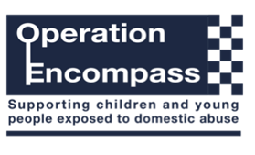

Friday 26th January 2024
Dear Parent/Carer,

Our school is part of a scheme in Sandwell that runs jointly between Education and West Midlands Police.

Operation Encompass is a police and Education safeguarding partnership that supports children and young people exposed to Domestic Abuse. It aims to ensure Schools are notified in a timely manner of any Domestic Abuse incident where a child was either present or registered at the address. This early notification should mean that, in most cases, schools are alerted in readiness for the children arriving at school the first working day following an incident.

Operation Encompass will also ensure that a member of the school staff, known as a Key Adult, is trained to allow them to liaise with the local authority and to use the information that has been shared, in confidence, while ensuring that the school is able to make provision for possible difficulties experienced by children, or their families, who have been involved in, or exposed to, a domestic abuse incident.

We are keen to offer the best support possible to all our pupils and we believe this will be extremely beneficial for all those involved

Yours faithfully,
M A Paine
Mark Paine
Principal

